GITLAB CICD1
Continuous Integration (CI)
- Runners: Gitlab Runner is an application that works with Gitlab CI/CD to run jobs in pipeline
- Shared Runners: its available to all groups and projects in a GitLab instance
- Group Runners: Available to all projects and subgroups in a group
- Specific runners: Associated with specific projects. Typically specific runners are used for one project at a time.
- Echo “This is a file “|tee file.txt : command for add contents to file.txt

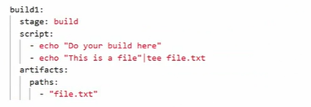
- Above commands is to create an artifact from the file.txt. The artifacts keyword helps on this, We need to mention the source file for creating artifacts inside artifacts keyword.

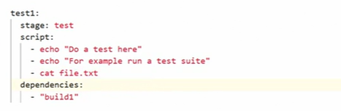
- With help of dependencies, We can pass the build stage to testing stage and this helps to test our artifacts and file

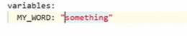
- Method to set variables inside script

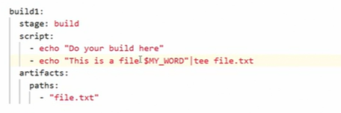
- Method to call variable inside our jobs.



- This is the output we can see inside our job details

Continuous Deployment (CD)
- Environments: The place where we deploy our Code .egg : Dev ,qa ,staging .Production.
- Environment path in Gitlab : Gitlab portal ->Deployments -> Environments
In your.gitlab-ci.yml file:

- Specify a name for the environment and optionally, a URL, which determines the deployment URL. For example:

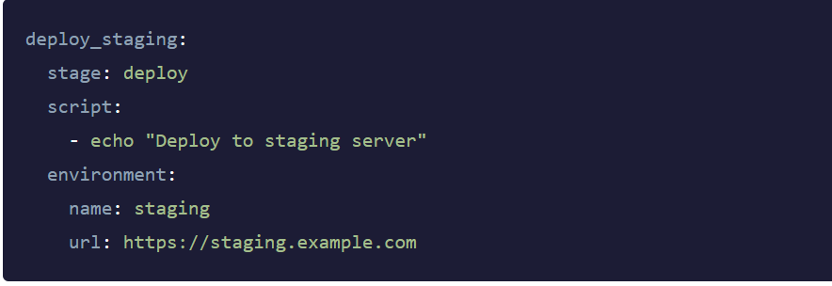

2.Trigger a deployment. (For example, by creating and pushing a commit.)
When the job runs, the environment and deployment are created.

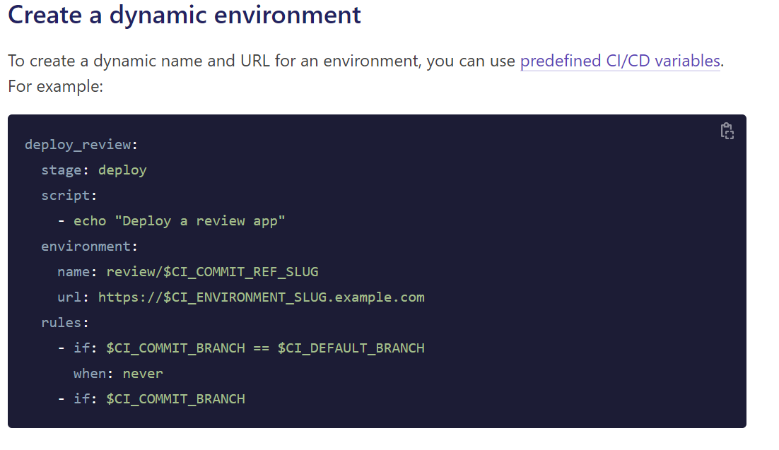

- The name is review/$CI_COMMIT_REF_SLUG. Because the environment name can contain slashes (/), you can use this pattern to distinguish between dynamic and static environments.
- For the url, you could use $CI_COMMIT_REF_SLUG, but because this value may contain a / or other characters that would not be valid in a domain name or URL, use $CI_ENVIRONMENT_SLUG instead. The $CI_ENVIRONMENT_SLUG variable is guaranteed to be unique.
……………………………………………………………………………………………………………………………………….
- Rules Keyword in the below example helps us to run deployment jobs manually
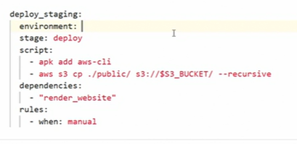
- Rules Keyword in the below example helps us to run deployment jobs automatically.

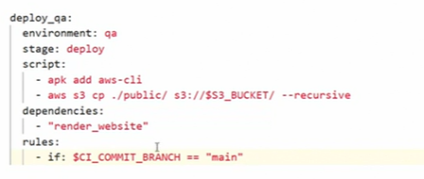

- In the staging job , it will run only if there is any tag added .otherwise it wont run .We use rules as below for this. $CI_COMMIT_TAG is Predefined variable in Gitlab

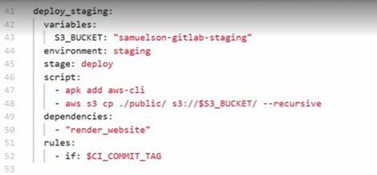

- In the deploy_prod job, it will run only if there is any tag added .otherwise it wont run .But for this prod job we have added manual deployment .

We use rules as below for this. $CI_COMMIT_TAG is Predefined variable in Gitlab also use When: Manual in addition to $COMMIT_TAG.

- If there is any bug found in after any deployment .We can roll back it to previous commit.

Path to roll back : gitlab portal ->Environments -> previous commit->Rollback
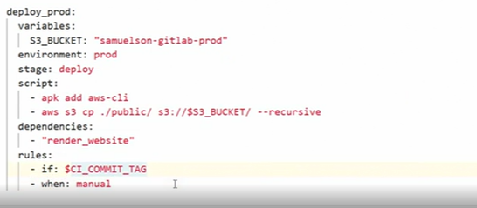

Gitlab notes from UDEMY Training
- A simple .gitlab-ci.yml file (artifacts query is not added, need to add it)

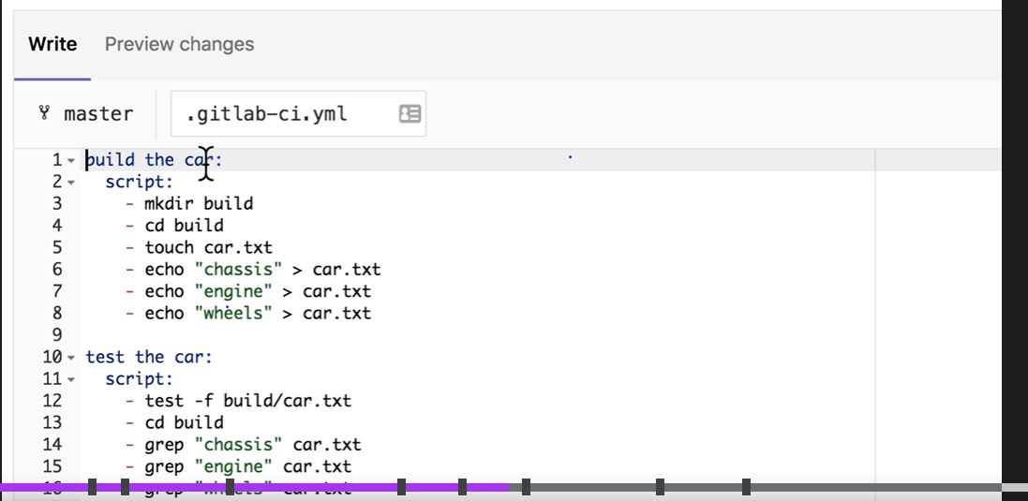

- Curl: Curl is a command line tool and library for transferring data with URL’s. it supports many protocols like http.

- Below is an example for CI/CD pipeline script
…………………………………………………………………………………………………………………………………………….
image: node
stages:
- build
- test
- deploy

build website:
stage: build
script:
- npm install
- npm install -g gatsby-cli
- gatsby build
artifacts:
paths:
- ./public

test artifact:
image: alpine
stage: test
script:
- grep -q "Gatsby" ./public/index.html

test website:
stage: test
script:
- npm install
- npm install -g gatsby-cli
- gatsby serve &
- sleep 3
- curl "http://localhost:9000" | tac | tac | grep -q "Gatsby"

deploy to surge:
stage: deploy
script:
- npm install --global surge
- surge --project ./public --domain instazone.surge.sh
……………………………………………………………………………………………………………………………………………
- Adding cache setup to the previous Script.
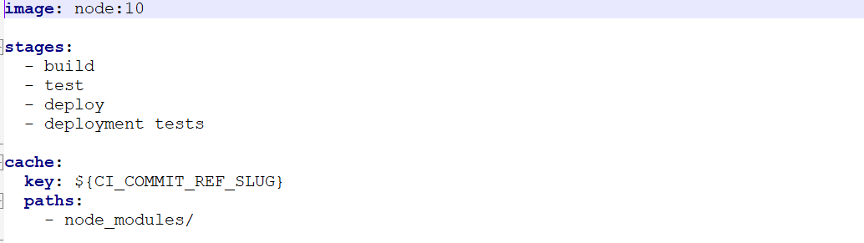
- Caching is a mechanism that can be used to save time when your jobs are running .Caching is about speeding the time a job is executed by reusing the same content of previous job
……………………………………………………………………………………………………………………………………………

Allow-failure:
Use allow_failure to determine whether a pipeline should continue running when a job fails.
- To let the pipeline continue running subsequent jobs, use allow_failure: true.
- To stop the pipeline from running subsequent jobs, use allow_failure: false.

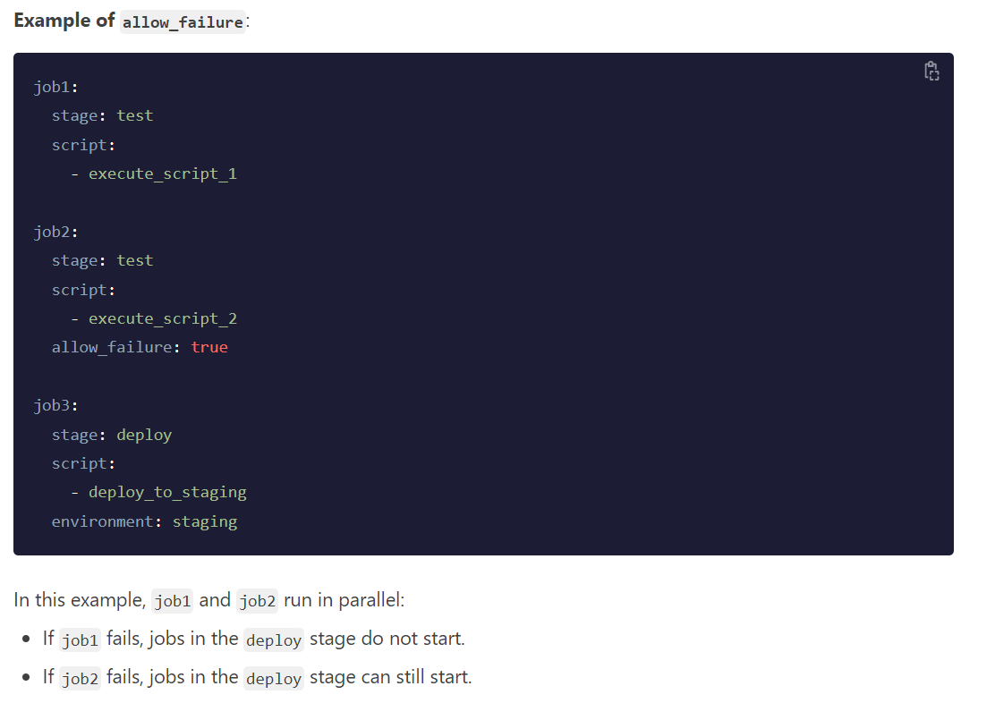

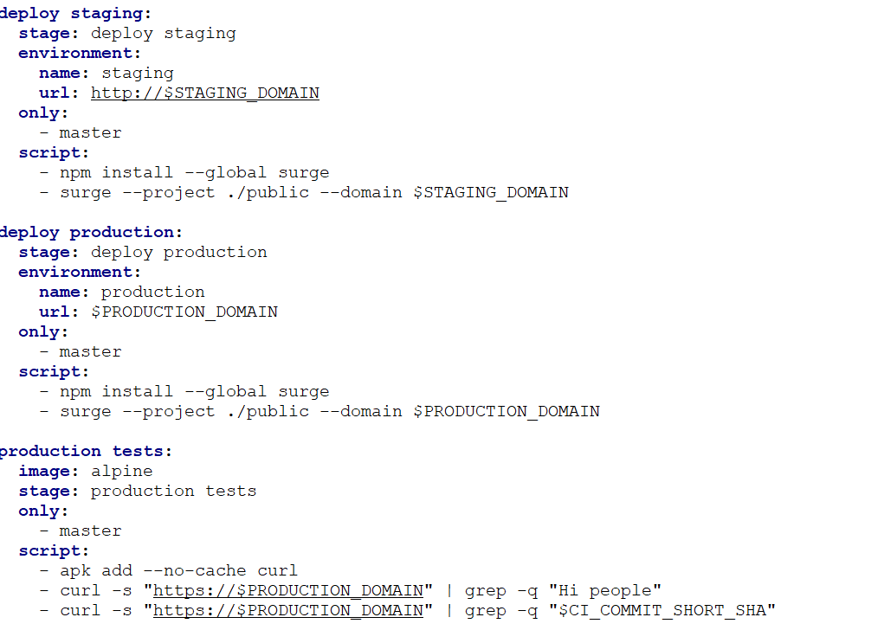

- Above is the example of using only command .It will help us to run our job in particular branch.
……………………………………………………………………………………………………………………………………………….
- Only:
  - Merge_requests

The above example is help to run the job inly if there is any Merge request.
……………………………………………………………………………………………………………………………………………….
- before_script and after_script
before_Script Used to defined commands/scripts that should run before the normal script block and it can be used locally or globally inside job.

- For disabling any jobs in our script just put a dot(.) Infront of job name.
Eg: .Deploy

- We can list all environment variables to a script with export command
Eg: job_name:
Script:
-export

